DISTRIBUTION AND DISSUASION EFFORTS OF CASPIAN TERNS (Hydroprogne caspia) ON EAST SAND ISLAND OF THE COLUMBIA RIVER: 2021 SEASON SUMMARY REPORT

Fisheries Field Unit
U.S. Army Corps of Engineers, Bonneville Lock and Dam, Cascade Locks, OR 97014

Christine M. Brandtner and Kyle S. Tidwell

Correspondence: Kyle.S.Tidwell@usace.army.mil

SUMMARY

To satisfy the requirements of several Biological Opinions that direct the U.S. Army Corps of Engineers to monitor the abundance and distribution of colonial piscivorous water birds on East Sand Island in the Columbia River Estuary, the Fisheries Field Unit conducted monitoring and dissuasion efforts of Caspian Terns (Hydroprogne caspia) between 5 April and 10 August, 2021. The objective of the work was to establish a one-acre colony for tern nesting, dissuade birds from nesting outside this colony, and enumerate the nesting attempts outside the colony. Here, we report that the dissuasion efforts were largely successful this season. The one-acre colony was established, Caspian Terns were enumerated, and nesting attempts were largely dissuaded in off-colony locations. Civilian Air Patrol flight photos and associated active nest counts are reported within this report for the first time. Similar to 2020 the main colony did not appear to be successful in fledging a Caspian Tern chick this year.

Table of Contents
List of Figures……………………………………………………………………………….…….2
List of Tables.………………………………………………………………………………….….2
Background…………………………………………………………………………………….….3
Methods….…………………………………………………………………………….…….…….4
Results………………………….………………………………………………………………….5
Discussion…………………………………………………………….…………………….….….6
Acknowledgements………………………………………………………………………….…….7
Literature Cited…………………………………………………………………………………....7
List of Figures
Figure 1. Looking east over the main Caspian Tern colony at ESI 11 May 2021...………………9
Figure 2. Tern Islands of the Lower Columbia River Estuary left to right: East Sand Island, Rice Island, Miller Sands, and Pillar Island…………………………………………………………...10
Figure 3. Aerial image of the eastern Portion of East Sand Island. Red polygons represent passive dissuasion materials. Blue dots indicate recorded CATE eggs…………….….…….…..10
Figure 4. Aerial image of the eastern tip of East Sand Island. Red polygons represent passive dissuasion materials. Blue and white dots indicate recorded CATE eggs……………………….11
List of Tables
Table 1. Monitoring data for Caspian Tern abundance and reproductive activity on East Sand Island in the Columbia River Estuary between 5 April and 10 August 2021.…………….…….11
Table 2. Raw monitoring data for Caspian Tern abundance and reproductive activity on East Sand Island in the Columbia River Estuary between 5 April and 10 August 2021……….…….12

BACKGROUND
Long term evaluation of Caspian Terns (CATE; Hydroprogne caspia, formerly Sterna caspia) and Double-Crested Cormorants (DCCO; Phalacrocorax auritus) in the Columbia River estuary has revealed that high concentrations of the birds can lead to significant impacts to some endangered salmonid stocks (Evans et al. 2012, 2019, Adkins et al. 2014). In response to the increased presence and abundance of these bird species in the Columbia River estuary, NOAA Fisheries issued a Biological Opinion (BiOp) in 1999 requiring the U.S. Army Corps of Engineers (USACE) to dissuade colonial water birds (i.e. CATE and DCCO) from nesting on USACE managed and operated lands in the estuary. These avian associated requirements of the 1999 BiOp have been reissued in every BiOp since and have led to complex management efforts to balance the impacts of avian predators on ESA listed salmonids while preserving the integrity of the avian populations in the Pacific Flyway (NOAA 1999, 2005, 2012).
Forming in 1984, the primary colony location for CATE was Rice Island (Figure 1), a USACE dredge material deposition site owned by the State of Oregon and Washington. The 1999 BiOp called for the USACE to relocate the Rice Island colony to the downstream site of East Sand Island (ESI) to minimize salmon consumption by increasing the level of estuarine and marine fishes in the CATE diet (Figure 1). East Sand Island is a USACE owned and operated site that has historically been used for dredge material deposition. In 2000, the CATE colony on Rice Island was successfully moved to East Sand Island and dietary monitoring showed that the intended dietary shift had occurred.
Following this action, an Environmental Impact Statement (EIS) was developed in 2005 as part of a lawsuit settlement agreement on tern management in the Columbia River estuary. The EIS evaluated a range of alternatives to reduce the Caspian tern population in the Columbia River estuary. The preferred alternative selected as the Caspian Tern Management Plan involved reducing the tern population by managing habitat on East Sand Island and redistributing a portion of the tern colony to created or enhanced sites outside of the Columbia River basin. The Action Agencies involved in developing the EIS were the United States Fish and Wildlife Service (USFWS), the USACE, and NOAA Fisheries; USFWS was the lead agency for the EIS and USACE and NOAA Fisheries were cooperating agencies. As a guidance document, the Management Plan establishes criteria for desired CATE colony size and breeding bird abundance in the Columbia River estuary; in order to minimize impacts to salmon while maintaining the integrity of the CATE breeding population across the Pacific Flyway.
Implementation of the 2005 EIS Management Plan required Records of Decision (ROD) by the USFWS and USACE, wherein the Action Agencies spelled out what they intended to do to achieve the goals and objectives of the Management Plan. These RODs are now referenced, in conjunction with the 2005 EIS, as the guiding documents of the CATE Management Plan, as well as subsequent decisions evaluated in National Environmental Policy Act (NEPA) Environmental Assessments which supplement and tier to the 2005 EIS. Chief among the CATE Management Plans objectives are: reduce the ESI breeding colony site to a minimum of one acre of suitable habitat which would theoretically reduce the number of breeding pairs of CATE to less than or equal to 3,125 pairs, and simultaneously mitigate for the loss of breeding sites by providing alternative inland avian breeding sites.
Concomitant to fulfilling these actions, the CATE management plan directs that: 1) an Adaptive Management Plan be developed for CATE actions beyond those directed by the EIS CATE Management Plan, and 2) once habitat objectives (the prepared one-acre colony) had been met on ESI, the responsibility for the work would transition from a short-term monitoring and research mission, to a long term Operations and Maintenance based monitoring mission. Once initiated, long-term management activities would operate to ensure: 1) CATE are not breeding outside of the one-acre colony at East Sand Island, and 2) provide colony estimates every three years to the USFWS for population monitoring metrics.
In 2018, the short-term monitoring objectives of the post construction habitat requirements were satisfied and the one-acre colony was established on ESI. Management of the East Sand Island CATE colony was transitioned to the Operations Division of the USACE Northwest Portland District. In January of 2019, the Fisheries Field Unit of the USACE began implementing the long-term monitoring mission of CATE on ESI. Below we detail the methods and results of the 2021 monitoring season.
METHODS
The one-acre CATE colony established in 2020 was repaired and used in 2021 (Figure 1). We established the colony boundaries with T posts and silt fence material. Passive dissuasion materials (T posts, ropes, and flagging) dissuaded CATE from near-colony areas and locations historically documented to be areas of nesting interest. As the season progressed and CATE showed interest in areas outside the colony that were not originally dissuaded, we deployed more dissuasion materials.
Sampling on East Sand Island involved boat-based surveys of off-colony CATE abundance counts and nesting attempts. Our methods included approaching the island from the boat and viewing, enumerating, and recording all CATE on the ground and outside the one-acre colony with field glasses. Biologists then landed on the island and worked transects in a south-westerly direction to enumerate nesting attempts (i.e., scrapes) outside of the one-acre colony. Historically, most scrapes have been found near the wrack line of the tidal waters, and the same pattern was observed this year. When a CATE scrape was identified, it was assessed for the presence of an egg. If no egg was present, we recorded the scrape and filled it with sand to dissuade future nesting attempts and enable accurate scrape enumeration. If an egg was observed, biologists record the nest from a distance greater than or equal to 15 feet, and continue with the sampling transect, leaving the nest undisturbed. We conducted the scrape enumeration walks in a uni-directional pattern as often as possible to minimize double counting of scrapes and eggs.
Our methods for enumerating the number of breeding pair of CATE used a combination of aerial imagery from fixed wing airplanes to ascertain the total number of CATE on colony and accounted for nest-attending vs. non nest-attending CATE. We captured the number of breeding pair by applying standardized sampling methods described by the Bird Research Northwest Field Protocol (BRNW, 2018). 12 m x 12 m study plots were deployed prior to the CATE arrival and were used to sub-sample the colony for the number of attending CATE pair. Using aerial images, we enumerated the total number of CATE present on colony during each flight. When aerial images were captured biologists in stilt blinds with 8x42 field glasses enumerated nest-attending versus non nest-attending terns concurrently within the study plots. These concurrent counts occurred three times total; including before, during and after the airplane flew over taking the aerial images of the one-acre colony. This method in conjunction with biweekly Civilian Air Patrol (CAP) flights allowed us to accurately enumerate and report the top three colony counts of breeding pair of CATE during the 2021 field season.
We collected and recorded the field data with the ARC GIS Collector Application©. This system allowed real-time analysis and processing of data and provided visual-spatial details for every datum.
We report the mean estimates and associated Standard Deviation for all results of the 2021 data. (Table 1).

RESULTS
Active dissuasion began on 5 April 2021 and concluded on 10 August 2021. We spent a total of 42 days on the island adding dissuasion, monitoring, and maintaining the colony perimeter. We collected data on 24 of the 42 days on the island and deployed 0.90 acres of passive dissuasion outside of the main colony (Figure 3, Figure 4).
We recorded an average of 572.3 ± S.D. 391.3 CATE per sample day (Table 1). We documented the first CATE scrapes on the south beach of ESI on 21 April (n = 119) (Table 2) and the south beach and east beach in aggregate, averaged 275 ± S.D.149.3 CATE scrapes per sample day (Table 1). We recorded the first CATE egg outside the main colony on 26 May (n = 2) (Table 2). The south beach and east beach, in aggregate, averaged 2.7 ± S.D. 3.6 CATE eggs per sample day (Table 1). No known CATE eggs hatched outside of the colony and no recorded fledglings were recorded on the main colony.
We report the top three colony counts from the 2021 season. The highest three counts were 8 June 2021 at 3,328 CATE, 25 June 2021 at 4,353 CATE and 11 July 2021 at 3,650 CATE. On the peak data, 25 June, we observed an average nest-attending vs. non nest-attending ratio of 2,050/2,303 CATE.
For contrast to historical data, we include the raw data from this year in Table 2.
DISCUSSION
The USACE successfully met the objectives established by the guiding documents. A one-acre CATE breeding colony was established, CATE abundance, scrape, and egg estimates outside of the colony were monitored and recorded, and nesting attempts outside of the one-acre colony were dissuaded. The 2021 results are similar to 2020, wherein there were no CATE eggs hatched on or off the colony. However, in 2021 there was approximately a 50% reduction in passive dissuasion (i.e., 2.11 acres in 2020 and 0.90 acres in 2021) and more time spent actively deterring CATE from off colony nesting attempts. This is a result of successful adaptive management. Crews in 2020 were faced with COVID induced travel restrictions and put up more passive dissuasion to account for less time on island. In 2021 crews had more access to the island and adaptively managed CATE scrape attempts with human presence and less ropes, stakes, and flagging. We spent 42 days on the island actively dissuading and monitoring nesting attempts off colony in 2021 contrasting with 31 days during the 2020 season.
The presence of predators (i.e. Gulls [Larus spp.], River Otters [Lontra Canadensis], Bald Eagle [Haliaeetus leucocephalus]) and hazing walks by USACE biologists functioned synergistically to deter the majority of CATE nesting attempts outside the one-acre colony. Observations that CATE egg survival off colony was nonexistent was confirmed by comparing the geo-spatial locations of each egg location between sample days. These rudimentary analyses suggest that most eggs deposited outside of the one-acre colony were depredated or destroyed naturally before the USACE biologists returned to sample the next visit.
Passive dissuasion efforts on the south beach and the outside colony areas were successful. However, the unsuccessful CATE colony suggests that ulterior factors likely influenced the unsuccessful CATE reproductive efforts this year and the successful dissuasion of the south beach and off-colony areas. It has been suggested that the increasing presence of Bald Eagles might affect the reproductive success of the CATE colony. Throughout the sampling season we documented several complete one-acre colony flushes every hour when working on the island.
The three top colony counts, and CATE nest counts are reported here for the first time. Historically these counts would be incorporated in estimates of per capita predation for the one-acre colony. We present these data here and report that PIT tags were collected from the one-acre colony then scanned and these data have been uploaded to PIT Tag Information Systems (PTAGIS) in October 2021.
ACKNOWLEDGEMENTS
We recognize the support of the Real Time Research Crew (Ken Collis, Allen Evens, and James Tennyson) and the Civilian Air Patrol Crew (Jonathan Ritchie). We also recognize the diligent monitoring efforts of FFU research staff that provided this data set. Thank you to: Deven McCanna, Steven Sachs, Bjorn van der Leeuw, and Robert Wertheimer.
References

Adkins, J.Y., D.E. Lyons, P.J. Loschl, D.D. Roby, K. Collis, A.F. Evans, and N.J. Hostetter. 2014. Demographics Of Piscivorous Colonial Waterbirds And Management Implications For ESA-Listed Salmonids On The Columbia Plateau. Northwest Science 88:344-359

Bird Research Northwest. Fish and Data Collections Protocols. East Sand Island. Stand Sit Protocols. 2018. Revised March 2018. 7-12 Pg.
Evans, A.F., N.J. Hostetter, D.D. Roby, K. Collis, D.E. Lyons, B.P. Sandford, And R.D. Ledgerwood. 2012. System-Wide Evaluation Of Avian Predation On Juvenile Salmonids From The Columbia River Based On Recoveries Of Passive Integrated Transponder Tags. Transactions of The American Fisheries Society 141:975-989.

Harper, J. and K. Collis. 2018. 2018 hazing and Dissuasion of Caspian Terns in the Lower Columbia Estuary: Season End Summary Report. 10 Pg.

NOAA Fisheries. 1999. Endangered Species Act – Section 7 Consultation Biological Opinion, Columbia River Navigation Channel Operation and Maintenance Dredging. NWR-1999-1150. Northwest Region. Seattle, Washington. September 15, 1999.

NOAA Fisheries. 2005. Endangered Species Act – Section 7 consultation biological opinion and conference opinion & Magnuson-Stevens Act Essential Fish Habitat Consultation, reinitiation of Columbia River Federal Navigation Channel improvements project. NMFS No. 2004/01612. Northwest Region. Seattle, Washington. February 16, 2005.

NOAA Fisheries. 2012. Reinitiation of Endangered Species Act Section 7 Formal Consultation and Magnuson-Stevens Fishery Conservation and Management Act Essential Fish Habitat Consultation for the Columbia River Navigation Channel Operations and Maintenance, Mouth of the Columbia River to Bonneville Dam, Oregon and Washington (HUCs 1708000605, 1708000307, 1708000108). NMFS No. 2011/02095. Northwest Region. Seattle, Washington. July 11, 2012.

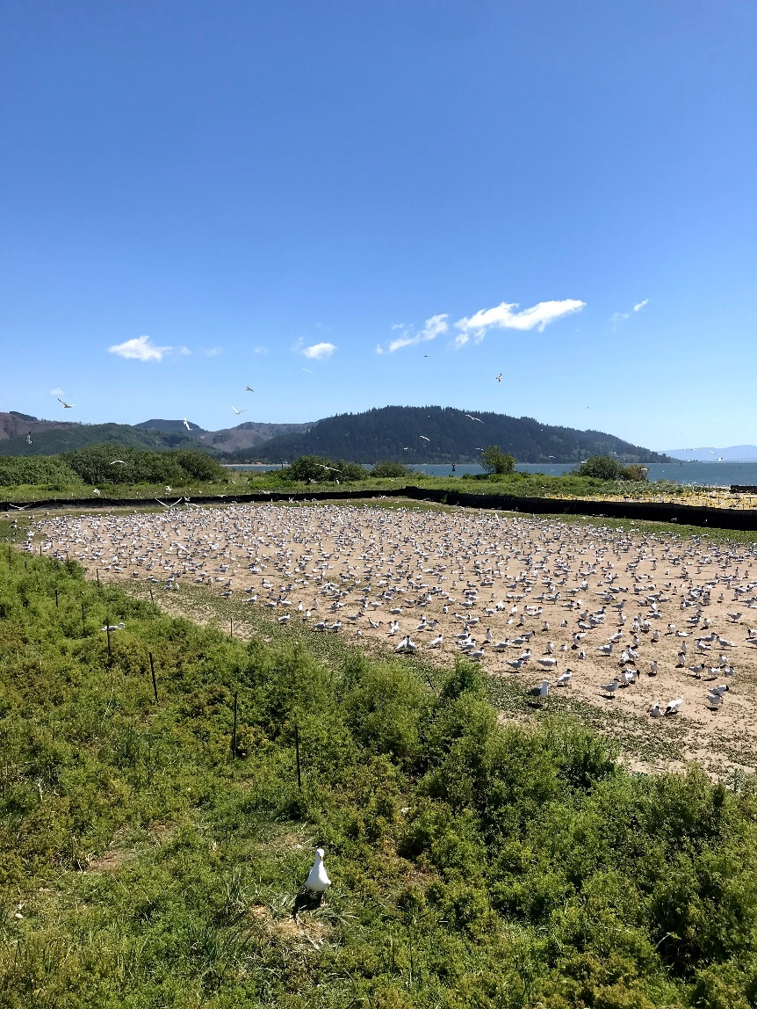

Figure 1. Looking east over the main Caspian Tern colony at East Sand Island 11 May 2021

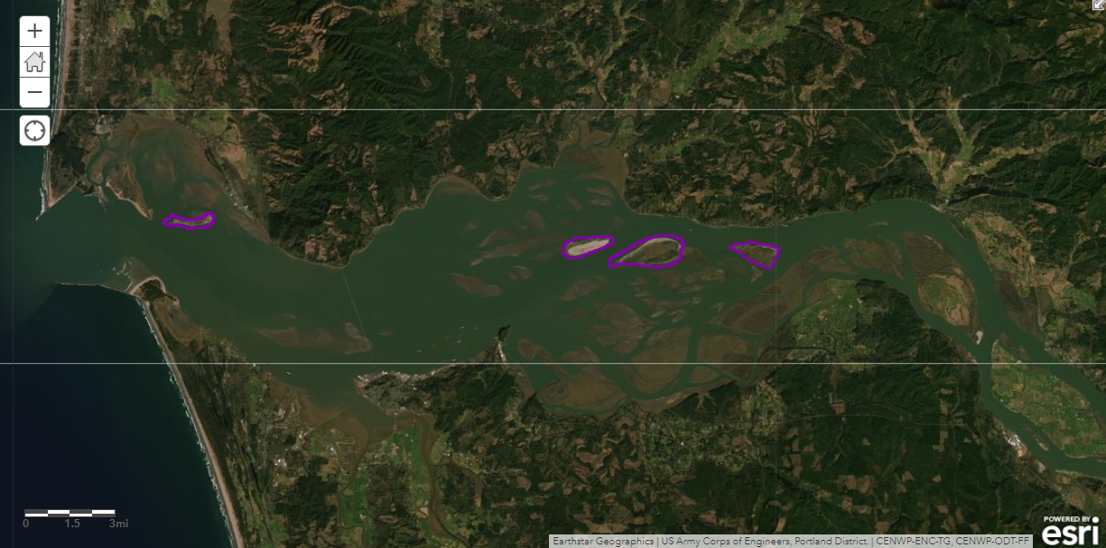
Figure 2. Tern Islands of the Lower Columbia River Estuary left to right: East Sand Island, Rice Island, Miller Sands, and Pillar Island.
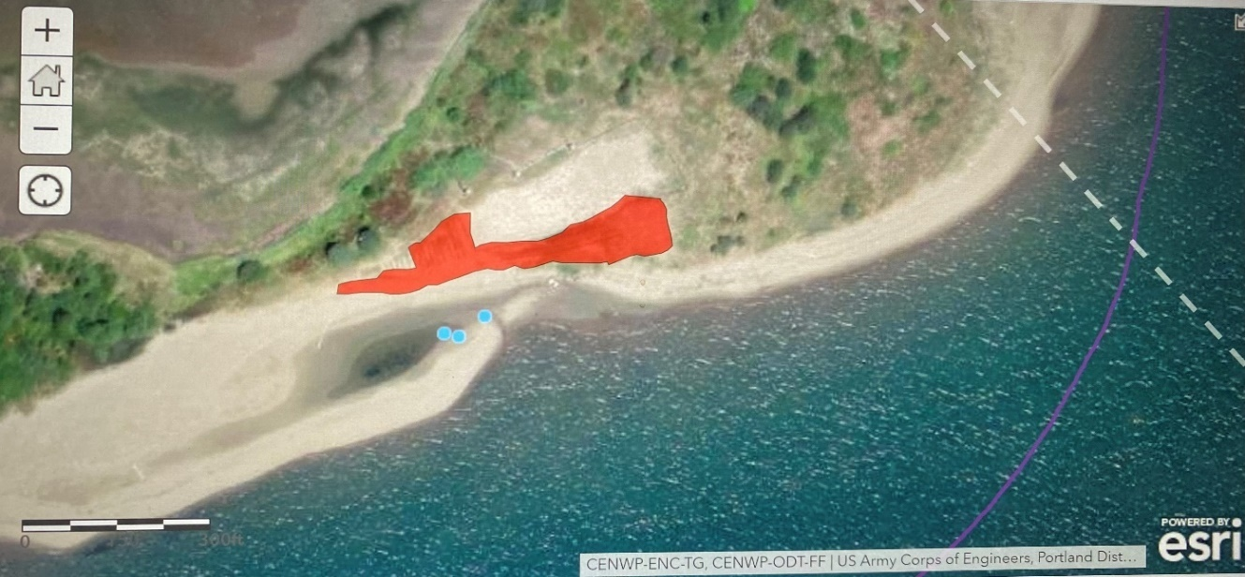
Figure 3. Aerial image of the eastern Portion of East Sand Island. Red polygons represent passive dissuasion materials. Blue dots indicate where CATE eggs have been recorded.
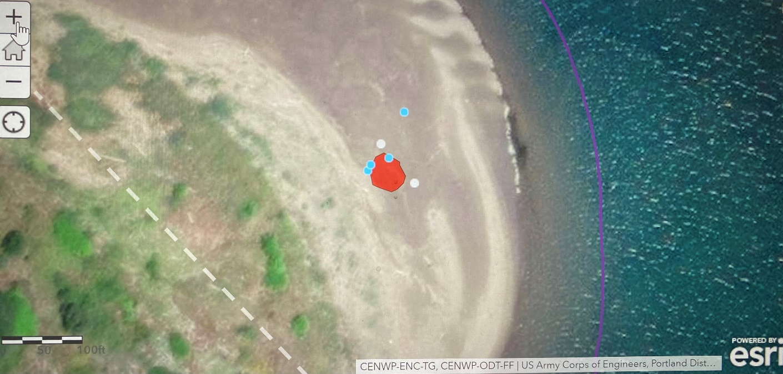
Figure 4. Aerial image of the far eastern tip of East Sand Island. Red polygons represent passive dissuasion materials. Blue and white dots indicate where CATE eggs have been recorded.

Table 1. Monitoring data for Caspian Tern abundance and reproductive activity outside of the main colony on East Sand Island in the Columbia River Estuary between 5 April and 10 August 2021.

Variable | n days monitored | $\overline{x}$± S.D. | Median | Range | $$n days=0$$
CATE Abundance | 24 | 572.3 ± 391.3 | 750 | 40- 1413 | 0
CATE  Scrape | 24 | 275 ± 149.3 | 278 | 26- 500 | 0
CATE  Egg | 24 | 2.75 ± 3.6 | 0 | 0 - 11 | 5

Table 2. Raw monitoring data for Caspian Tern abundance and reproductive activity on East Sand Island in the Columbia River Estuary between 5 April and 10 August 2021.
Date 2021 | # CATE Eggs | # CATE Scrapes | # CATE Outside Colony
5-Apr | - | - | 40
7-Apr | - | - | 60
21-Apr | - | 119 | 1180
3-May | - | - | 720
11-May | - | 80 | 580
18-May | 0 | 316 | 590
20-May | 0 | 243 | 558
26-May | 2 | 359 | 1413
3-Jun | 4 | 413 | 1400
7-Jun | 8 | 329 | 920
8-Jun | 5 | 475 | -
9-Jun | 2 | 477 | 730
11-Jun | 11 | - | -
16-Jun | - | 233 | 625
23-Jun | 0 | 293 | 483
28-Jun | - | - | 361
1-Jul | 1 | 361 | 263
7-Jul | - | 500 | 500
8-Jul | - | - | 190
14-Jul | - | - | 120
15-Jul | - | 150 | -
22-Jul | 0 | 231 | 335
29-Jul | 0 | 70 | 525
10-Aug | - | 26 | 425

